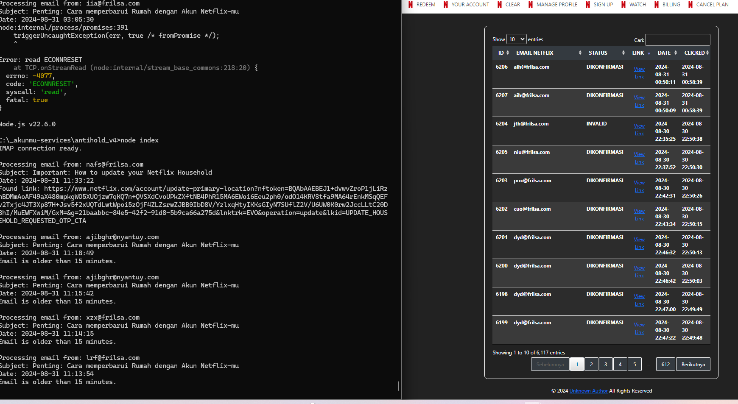

Mati jam 00.58

Running ulang jam 11.38